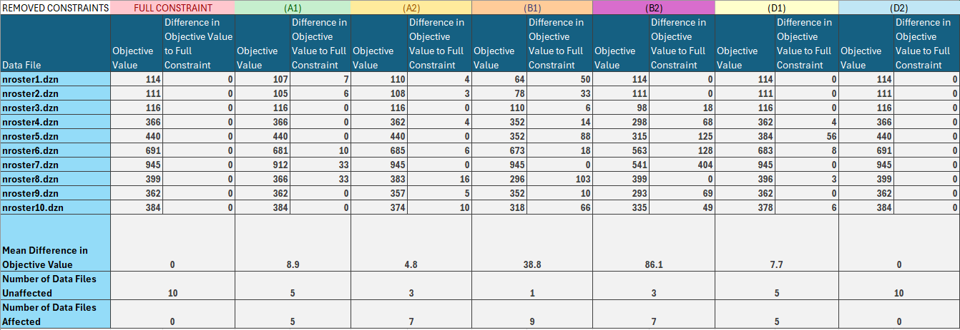**Table for Objective Value and Difference**

**Table for Time Taken of each run**

**Analysis for nroster01.dzn**

**Level of Importance**

**B1** (Difference = 50) -> **A1** (Difference = 7) -> **A2** (Difference = 4) -> **Others** (Difference = 0)

B1 has the largest effects on the objective value since every nurse are assigned a particular minimum shift to fulfil for this datafile which means that by removing it, the solutions that uses only early shifts are possible and avoids night shifts which are highly restrictive in terms of its transitions. The effect of A1 is less significant due to lesser rostered_off shifts. A2’ effects are not significant since the model can only exploit the constraint (every shift OFF which is the most effective for reducing cost) for only one nurse. B2 does not affect the results due to maxweek being 7, maxnightfort being 6, and minfort being 0 (which essentially renders the constraint pointless). Part D has no effect as well due to there being only one ward.

**Analysis for nroster02.dzn**

**Level of Importance**

**B1** (Difference = 33) -> **A1** (Difference = 6) -> **A2** (Difference = 3) -> **Others** (Difference = 0)

Similar phenomenon can be found here as nroster01.dzn since both datasets are structurally similar. The reasoning is mostly same, apart from the smaller effects in removing B1. This is due to the lesser amount of minshifts (more 0 within the array) which leads to the overall solution being less constrained by the B1. The lack of effect for B2 is also similar since the rostered off number has increased alongside the changes in maxweek to 6 so the possible slots to put night shifts is already greatly restricted.

**Analysis for nroster03.dzn**

**Level of Importance**

**B2** (Difference = 18) -> **B1** (Difference = 6) -> **Others** (Difference = 0)

B2 has a significant effect for nroster03 since minfort is 8 which forces there to be more shifts assigned to nurses than if B2 is removed. Maxnightfort is also high which forces more night shifts to be assigned. B1 also has a similar but lesser effect on the objective value since the minshift value contains a good amount of 0s (no lower bound of nurses required) and alongside the false rostered_off table makes it incredibly unrestricted anyways. As we mentioned all values in the rostered_off table are set to 0 which means that Part A will have no effect whether they are included or not and Part D has no effect as well due to there being only one possible ward choice.

**Analysis for nroster04.dzn**

**Level of Importance**

**B2** (Difference = 68) -> **B1** (Difference = 14) -> **A2,D1** (Difference = 4) -> **Others** (Difference = 0)

Again, B2 has a significant effect since it has the same values as nroster03 with a high minfort and high maxnightfort. The difference is more significant here due to the rostered_off table not being set fully to false, which restricts the number of slots we can put shifts in and in turn making the difference in the amount of night shifts assigned more significant since they are more restrictive in its transitions. The minshift array also contains higher numbers and less 0 which further reduces our search space thus increasing its impact on the objective value when removed. A1 has a small effect when removed due to the rostered_off table not being fully false and D1 also has a small effect due to the introduction of an additional ward. A2 has no effect due to other constraints already restricting the search space fully and D2 has no effect since maxward is equal to the number of wards.

**Analysis for nroster05.dzn**

**B2** (Difference = 125) -> **B1** (Difference = 88) ->**D1** (Difference = 56) -> **Others** (Difference = 0)

This data set has the same maxweek, maxnightfort and minfort values as nroster03, with the only difference being the nday being 14, which makes the overall objective value (and in turn the difference) higher. Thus, the effects of B2 have the same justification. B1 however plays a larger role here since the minshift are all set to 2, which heavily constraints our search space so removing it will have a larger effect when compared to the similar dataset in nroster03. D1 also has an effect due to most minward being set to high numbers like 9-10 which essentially forces 9-10 nurses to be assigned shifts on those days to fulfil that requirement. Part A has no effects due to the problem already being heavily constrained by other constraints and D2 has no effect as well since maxward is 2 and there is only one ward choice.

**Analysis for nroster06.dzn**

**B2** (Difference = 128) > **B1** (Difference = 18) > **A1** (Difference = 19) > **D1** (Difference = 8) > **A2** (Difference = 6) **> Others** (Difference = 0)

Effects of B2 are same as nroster03,04,05. B1 has a small effect due to the large number of 0s in the array. A1 also has an effect since rostered_off contains a small but meaningful amount of false which suggests that more shifts might be arranged without enforcing it. D1 has a smaller effect since we have 2 wards but with some days enforcing 9 nurses to be on shift (compared to nroster05) and A2 has also a small effect since there is a possibility of three off shifts since some rostered_off values are set to false consecutively.

**Analysis for nroster07.dzn**

**B2 (**Difference = 404) > **A1 (**Difference = 33) > **Others (**Difference = 0)

B2 has a large effect here due to the large minfort value which forces more shifts to be added so removing it might allow more off shifts to be assigned instead. A1 also has a small effect here since there is only a small amount of rostered_off shift so removing it expands our search space and allows for more optimal options. A2 has no effect due to other constraints already restricting the search space substantially and B1 and Part D has no effect since minshift and minward are sufficiently low and maxward is also only set to 3 so the large number of nurses offsets these constraints.

**Analysis for nroster08.dzn**

**B1** (Difference = 103) -> **A1** (Difference = 33) -> **A2** (Difference = 16) -> **D1** (Difference = 3) -> **Others** (Difference = 0)

B1 has the highest effect here since it forces 6 nurses to be on shift for some days which severely restricts our search space so removing it has a large impact on the objective value as well. A1 and A2 both have a smaller impact since the rostered_off array contains a good number of off shifts (with some being consecutive) so removing them would either increase the number of off shifts or allow for consecutive off shifts. D1 has some effect since only some wards have minward values. B2 and D2 has not effects since minfort is low at only 6 and maxward is equal to total ward choices.

**Analysis for nroster09.dzn**

**B2** (Difference = 69) -> **B1** (Difference = 10) -> **A2** (Difference = 5) -> **Others** (Difference = 0)

B2 has a large effect due to minfort being 8 which forces a higher number of shifts. B1 has a smaller effect since there are some days where minshift forces at least 6 nurses to be on shift and A2 also has a small effect since it restricts 3 consecutive off shifts and reduces night shifts permitted (which are more restrictive). A1 has no difference since the rostered_off array does not contain that many true values and Part D is not relevant since minward is small for most days and maxward is small as well when compared when the choices of nurses available.

**Analysis for nroster09.dzn**

**B1** (Difference = 66) -> **B2** (Difference = 49) -> **A2** (Difference = 10) -> **D1**(Difference =6) -> **Others** (Difference = 0)

B1 here has a large effect since the minshift values are extremely high compared to the number of nurses available so more nurses are forced to be on shift. B2 also has a significant effect since maxnightfort is set to 6 which allows more night shifts (which are more restrictive). A2 and D1 only has a small effect since removing A2 allows some sequences with more than 3 OFF shifts in a row and minward value is sufficiently high compared to the number of nurses that it restricts our search space. D2 has no effects since maxward is set to 3 when we have 4 distinct wards.

**Overall Effects of Constraints**

Overall, we have computed the mean difference for all constraint and the most important one seems to be B2. The model is extremely sensitive to the minfort and maxnightfort value since they directly force there to be more night shifts and just shifts in general. These can increase the objective functions significantly since night shifts are heavily restrictive in terms of what shifts can follow them so our search space in turn gets reduced significantly as well. B1 ranks second since minshift values also forces there to be more shifts since there are a lot of cases where the data essentially forces most of the nurses to be on duty. These are followed by D1 and A1 which are close in terms of impact since A1 only effects data sets where the rostered_off array is restrictive enough to reduce our search space whereas D1 only affects datasets where minward is high. D2 ranks the lowest with 0 effect across all datasets since the maxward numbers for all the datasets are either sufficiently small such that they search space is not restricted or that the maxward is equivalent to the number of wards which makes the constraint pointless.